 | Computer Architecture and Assembly Language Programming (Practical)  Assignment No. 1  (Solution) | Total marks = 20  Deadline:  Expired
Please carefully read the following instructions before attempting assignment.
RULES FOR MARKING
It should be clear that your assignment would not get any credit if:
- The assignment is submitted after the due date.
- The submitted assignment does not open or file is corrupt.
- Strict action will be taken if submitted solution is copied from any other student or from the internet.

You should concern the recommended books to clarify your concepts as handouts are not sufficient.
You are supposed to submit your assignment in .doc or docx format.
Any other formats like scan images, PDF, zip, rar, ppt and bmp etc. will not be accepted.
Labs covered: 1-3
Topics covered: addressing modes, branching techniques, and conditional/unconditional jumps

NOTE
No assignment will be accepted after the due date via email in any case (whether it is the case of load shedding or internet malfunctioning). Hence refrain from uploading assignment in the last hour of the deadline. It is recommended to upload your solution file at least two days before its closing date.
If you find any mistake or confusion in the assignment (Question statement), please contact your instructor before the deadline. After the deadline, no queries will be entertained in this regard.
For any query, feel free to email at cs401p@vu.edu.pk

Write an assembly language program to perform the following tasks:
- Store the numeric part (9 digits) of your VUID in memory.
- Multiply the first four digits and save the result in memory.
- Multiply the last four digits and store the value in the DX register.
- Compute the factorial of the fifth digit in the BX register.
- Add the results from steps (b), (c), and (d), and place the final value in the DX register.

Submission details:
Submit the following in MS-Word document:
- Assembly language program.
- Screenshot of AFD debugger showing the final result in the DX register.

Solution:
[org 0x0100]
jmp start
vuid: db 1,2,3,4,5,6,7,8,9
firstTask: dw 0
start:
; (b) Multiply first four digits
mov al, [vuid+0]
mov bl, [vuid+1]
mul bl
mov bl, [vuid+2]
mul bl
mov bl, [vuid+3]
mul bl
mov [firstTask], ax

; (c) Multiply last four digits
mov ax, 0
mov al, [vuid+5]
mov bl, [vuid+6]
mul bl
mov bx, [vuid+7]
xor bh, bh
mul bl
mov bx, [vuid+8]
xor bh, bh
mul bx
mov dx, ax

; (d) Factorial of 5th digit
mov cl, [vuid+4] ; 5th digit
mov bx, 1
fact_loop:
cmp cl, 1
jbe fact_done
mov ax, bx
mul cl
mov bx, ax
dec cl
jmp fact_loop
fact_done:
mov bx, ax

; (e) Add all results
add dx, [firstTask]
add dx, bx

mov ax, 0x4c00
int 0x21
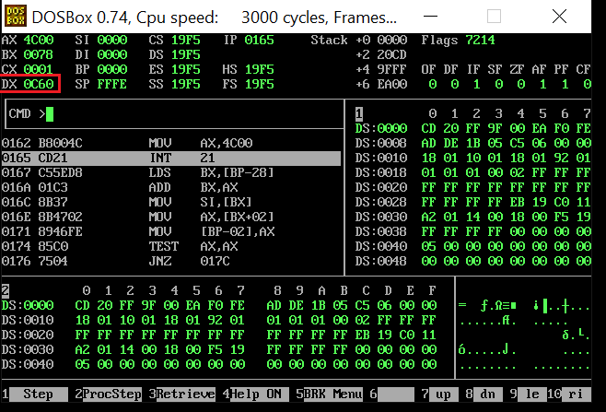
The End

